HERTZIAN DIPOLE

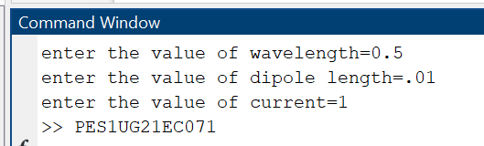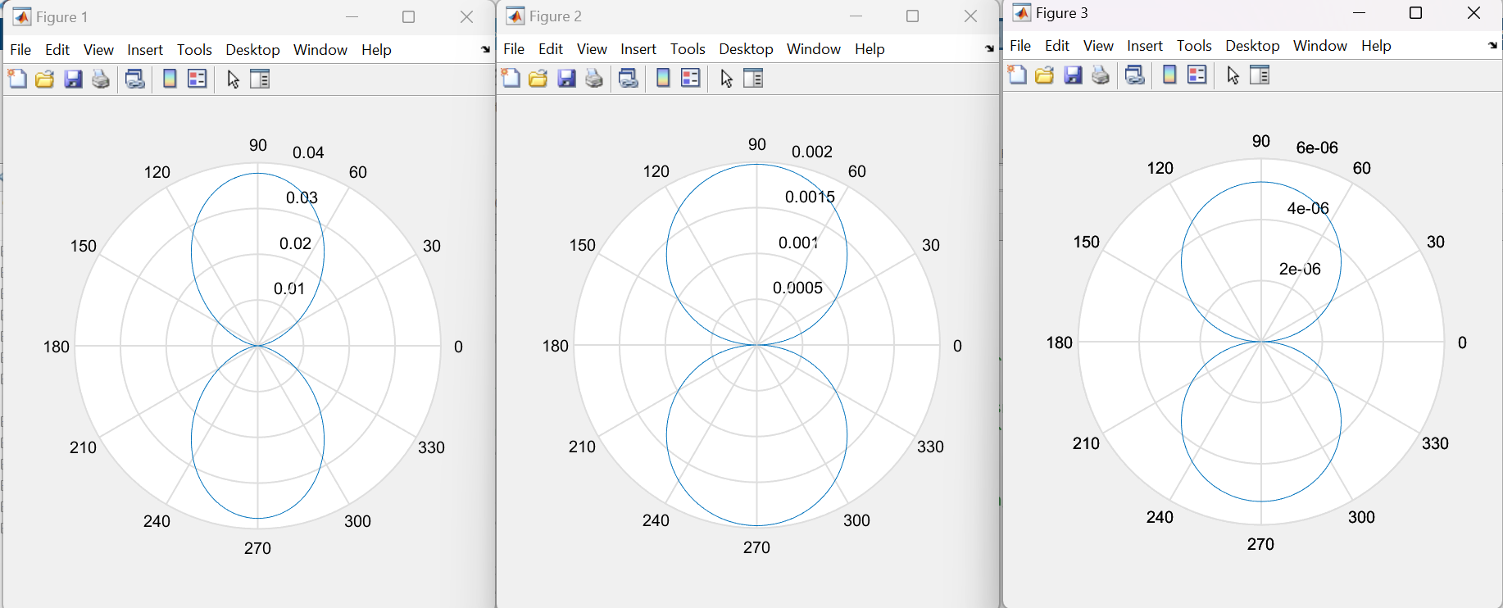

PES1UG21EC071

SHORT DIPOLE

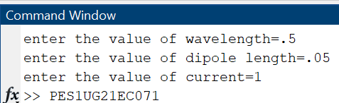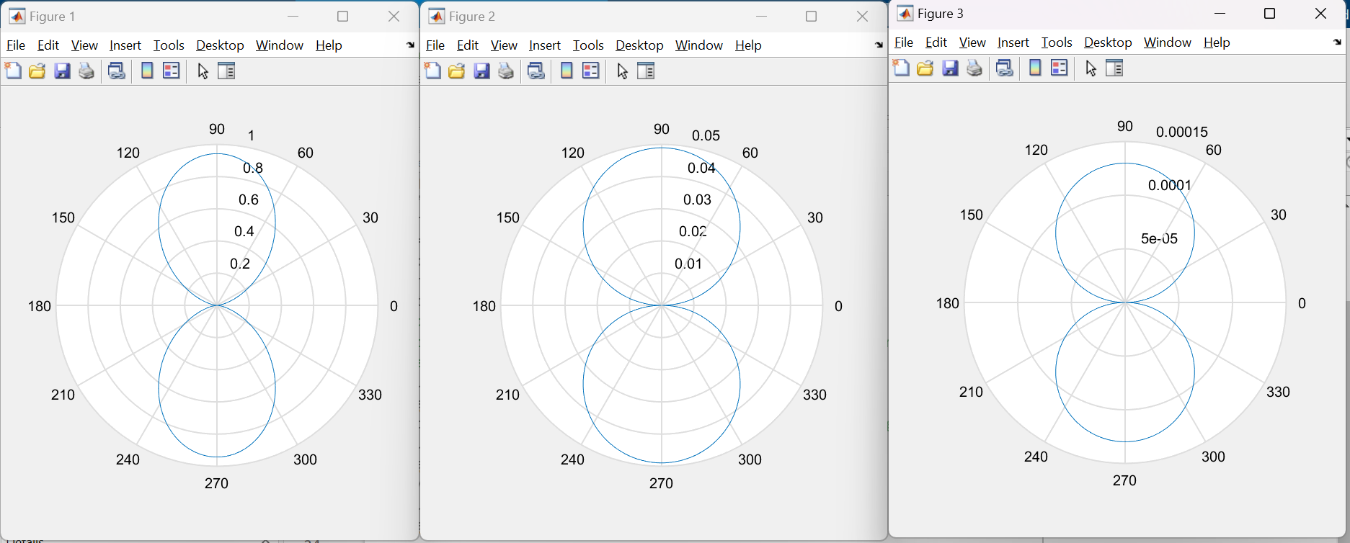

PES1UG21EC071

LAMBDA/2

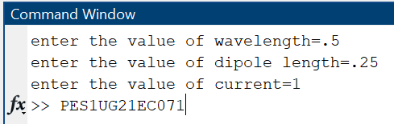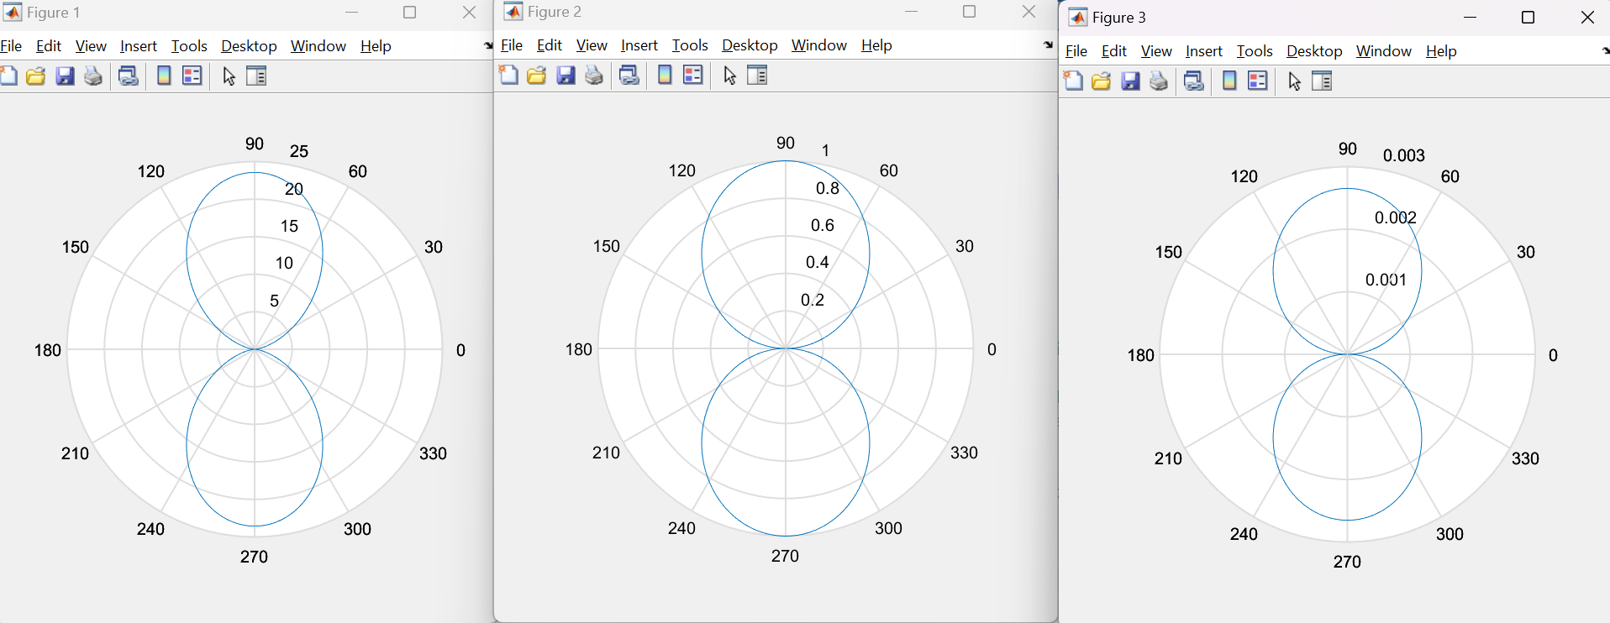

PES1UG21EC071

FINITE LENGTH DIPOLE

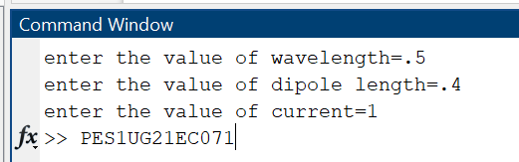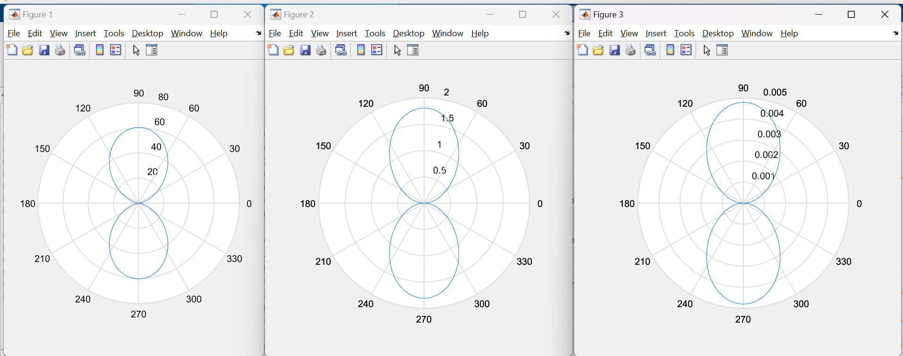

PES1UG21EC071